Introduction to data

Some define Statistics as the field that focuses on turning information into knowledge. The first step in that process is to summarize and describe the raw information - the data. In this lab, you will gain insight into public health by generating simple graphical and numerical summaries of a data set collected by the Centers for Disease Control and Prevention (CDC). As this is a large data set, along the way you’ll also learn the indispensable skills of data processing and subsetting.

## Getting started

The Behavioral Risk Factor Surveillance System (BRFSS) is an annual telephone survey of 350,000 people in the United States. As its name implies, the BRFSS is designed to identify risk factors in the adult population and report emerging health trends. For example, respondents are asked about their diet and weekly physical activity, their HIV/AIDS status, possible tobacco use, and even their level of healthcare coverage. The BRFSS Web site (<http://www.cdc.gov/brfss>) contains a complete description of the survey, including the research questions that motivate the study and many interesting results derived from the data.

We will focus on a random sample of 20,000 people from the BRFSS survey conducted in 2000. While there are over 200 variables in this data set, we will work with a small subset.

We begin by loading the data set of 20,000 observations into the R workspace. After launching RStudio, enter the following command.

source("more/cdc.R")

The data set cdc that shows up in your workspace is a *data matrix*, with each row representing a *case* and each column representing a *variable*. R calls this data format a *data frame*, which is a term that will be used throughout the labs.

To view the names of the variables, type the command

names(cdc)

This returns the names genhlth, exerany, hlthplan, smoke100, height, weight, wtdesire, age, and gender. Each one of these variables corresponds to a question that was asked in the survey. For example, for genhlth, respondents were asked to evaluate their general health, responding either excellent, very good, good, fair or poor. The exerany variable indicates whether the respondent exercised in the past month (1) or did not (0). Likewise, hlthplan indicates whether the respondent had some form of health coverage (1) or did not (0). The smoke100 variable indicates whether the respondent had smoked at least 100 cigarettes in her lifetime. The other variables record the respondent’s height in inches, weight in pounds as well as their desired weight, wtdesire, age in years, and gender.

1. How many cases are there in this data set? How many variables? For each variable, identify its data type (e.g. categorical, discrete).

dim(cdc); str(cdc); sapply(cdc, function(x) length(unique(x)))

## [1] 20000 9

## 'data.frame': 20000 obs. of 9 variables:  
## $ genhlth : Factor w/ 5 levels "excellent","very good",..: 3 3 3 3 2 2 2 2 3 3 ...  
## $ exerany : num 0 0 1 1 0 1 1 0 0 1 ...  
## $ hlthplan: num 1 1 1 1 1 1 1 1 1 1 ...  
## $ smoke100: num 0 1 1 0 0 0 0 0 1 0 ...  
## $ height : num 70 64 60 66 61 64 71 67 65 70 ...  
## $ weight : int 175 125 105 132 150 114 194 170 150 180 ...  
## $ wtdesire: int 175 115 105 124 130 114 185 160 130 170 ...  
## $ age : int 77 33 49 42 55 55 31 45 27 44 ...  
## $ gender : Factor w/ 2 levels "m","f": 1 2 2 2 2 2 1 1 2 1 ...

## genhlth exerany hlthplan smoke100 height weight wtdesire age   
## 5 2 2 2 38 237 178 81   
## gender   
## 2

# (1) we have 20000 cases and 9 variables. genhlth is categorical (ordinal); exerany, hlthplan, and smoke100 are discrete (binary); height, weight, wtdesire, and age are discrete; and gender is categorical (nominal).

We can have a look at the first few entries (rows) of our data with the command

head(cdc)

and similarly we can look at the last few by typing

tail(cdc)

You could also look at *all* of the data frame at once by typing its name into the console, but that might be unwise here. We know cdc has 20,000 rows, so viewing the entire data set would mean flooding your screen. It’s better to take small peeks at the data with head, tail or the subsetting techniques that you’ll learn in a moment.

## Summaries and tables

The BRFSS questionnaire is a massive trove of information. A good first step in any analysis is to distill all of that information into a few summary statistics and graphics. As a simple example, the function summary returns a numerical summary: minimum, first quartile, median, mean, second quartile, and maximum. For weight this is

summary(cdc$weight)

R also functions like a very fancy calculator. If you wanted to compute the interquartile range for the respondents’ weight, you would look at the output from the summary command above and then enter

190 - 140

R also has built-in functions to compute summary statistics one by one. For instance, to calculate the mean, median, and variance of weight, type

mean(cdc$weight)   
var(cdc$weight)  
median(cdc$weight)

While it makes sense to describe a quantitative variable like weight in terms of these statistics, what about categorical data? We would instead consider the sample frequency or relative frequency distribution. The function table does this for you by counting the number of times each kind of response was given. For example, to see the number of people who have smoked 100 cigarettes in their lifetime, type

table(cdc$smoke100)

or instead look at the relative frequency distribution by typing

table(cdc$smoke100)/20000

Notice how R automatically divides all entries in the table by 20,000 in the command above. This is similar to something we observed in the Introduction to R; when we multiplied or divided a vector with a number, R applied that action across entries in the vectors. As we see above, this also works for tables. Next, we make a bar plot of the entries in the table by putting the table inside the barplot command.

barplot(table(cdc$smoke100))

Notice what we’ve done here! We’ve computed the table of cdc$smoke100 and then immediately applied the graphical function, barplot. This is an important idea: R commands can be nested. You could also break this into two steps by typing the following:

smoke <- table(cdc$smoke100)  
  
barplot(smoke)

Here, we’ve made a new object, a table, called smoke (the contents of which we can see by typing smoke into the console) and then used it in as the input for barplot. The special symbol <- performs an *assignment*, taking the output of one line of code and saving it into an object in your workspace. This is another important idea that we’ll return to later.

1. Create a numerical summary for height and age, and compute the interquartile range for each. Compute the relative frequency distribution for gender and exerany. How many males are in the sample? What proportion of the sample reports being in excellent health?

summary(cdc$height); IQR(cdc$height)

## Min. 1st Qu. Median Mean 3rd Qu. Max.   
## 48.00 64.00 67.00 67.18 70.00 93.00

## [1] 6

summary(cdc$age); IQR(cdc$age)

## Min. 1st Qu. Median Mean 3rd Qu. Max.   
## 18.00 31.00 43.00 45.07 57.00 99.00

## [1] 26

g <- table(cdc$gender); g; prop.table(g)

##   
## m f   
## 9569 10431

##   
## m f   
## 0.47845 0.52155

t <- table(cdc$exerany); t; prop.table(t)

##   
## 0 1   
## 5086 14914

##   
## 0 1   
## 0.2543 0.7457

prop.table(table(cdc$genhlth))

##   
## excellent very good good fair poor   
## 0.23285 0.34860 0.28375 0.10095 0.03385

# (2) please see summary, IQR and tables from above. There are 9569 males and 23% reported that they are in excellent health.

The table command can be used to tabulate any number of variables that you provide. For example, to examine which participants have smoked across each gender, we could use the following.

table(cdc$gender,cdc$smoke100)

Here, we see column labels of 0 and 1. Recall that 1 indicates a respondent has smoked at least 100 cigarettes. The rows refer to gender. To create a mosaic plot of this table, we would enter the following command.

mosaicplot(table(cdc$gender,cdc$smoke100))

We could have accomplished this in two steps by saving the table in one line and applying mosaicplot in the next (see the table/barplot example above).

1. What does the mosaic plot reveal about smoking habits and gender?

# (3) Males are more likely to smoke than females.

## Interlude: How R thinks about data

We mentioned that R stores data in data frames, which you might think of as a type of spreadsheet. Each row is a different observation (a different respondent) and each column is a different variable (the first is genhlth, the second exerany and so on). We can see the size of the data frame next to the object name in the workspace or we can type

dim(cdc)

which will return the number of rows and columns. Now, if we want to access a subset of the full data frame, we can use row-and-column notation. For example, to see the sixth variable of the 567th respondent, use the format

cdc[567,6]

which means we want the element of our data set that is in the 567th row (meaning the 567th person or observation) and the 6th column (in this case, weight). We know that weight is the 6th variable because it is the 6th entry in the list of variable names

names(cdc)

To see the weights for the first 10 respondents we can type

cdc[1:10,6]

In this expression, we have asked just for rows in the range 1 through 10. R uses the : to create a range of values, so 1:10 expands to 1, 2, 3, 4, 5, 6, 7, 8, 9, 10. You can see this by entering

1:10

Finally, if we want all of the data for the first 10 respondents, type

cdc[1:10,]

By leaving out an index or a range (we didn’t type anything between the comma and the square bracket), we get all the columns. When starting out in R, this is a bit counterintuitive. As a rule, we omit the column number to see all columns in a data frame. Similarly, if we leave out an index or range for the rows, we would access all the observations, not just the 567th, or rows 1 through 10. Try the following to see the weights for all 20,000 respondents fly by on your screen

cdc[,6]

Recall that column 6 represents respondents’ weight, so the command above reported all of the weights in the data set. An alternative method to access the weight data is by referring to the name. Previously, we typed names(cdc) to see all the variables contained in the cdc data set. We can use any of the variable names to select items in our data set.

cdc$weight

The dollar-sign tells R to look in data frame cdc for the column called weight. Since that’s a single vector, we can subset it with just a single index inside square brackets. We see the weight for the 567th respondent by typing

cdc$weight[567]

Similarly, for just the first 10 respondents

cdc$weight[1:10]

The command above returns the same result as the cdc[1:10,6] command. Both row-and-column notation and dollar-sign notation are widely used, which one you choose to use depends on your personal preference.

## A little more on subsetting

It’s often useful to extract all individuals (cases) in a data set that have specific characteristics. We accomplish this through *conditioning* commands. First, consider expressions like

cdc$gender == "m"

or

cdc$age > 30

These commands produce a series of TRUE and FALSE values. There is one value for each respondent, where TRUE indicates that the person was male (via the first command) or older than 30 (second command).

Suppose we want to extract just the data for the men in the sample, or just for those over 30. We can use the R function subset to do that for us. For example, the command

mdata <- subset(cdc, cdc$gender == "m")

will create a new data set called mdata that contains only the men from the cdc data set. In addition to finding it in your workspace alongside its dimensions, you can take a peek at the first several rows as usual

head(mdata)

This new data set contains all the same variables but just under half the rows. It is also possible to tell R to keep only specific variables, which is a topic we’ll discuss in a future lab. For now, the important thing is that we can carve up the data based on values of one or more variables.

As an aside, you can use several of these conditions together with & and |. The & is read “and” so that

m_and_over30 <- subset(cdc, gender == "m" & age > 30)

will give you the data for men over the age of 30. The | character is read “or” so that

m_or_over30 <- subset(cdc, gender == "m" | age > 30)

will take people who are men or over the age of 30 (why that’s an interesting group is hard to say, but right now the mechanics of this are the important thing). In principle, you may use as many “and” and “or” clauses as you like when forming a subset.

1. Create a new object called under23_and_smoke that contains all observations of respondents under the age of 23 that have smoked 100 cigarettes in their lifetime. Write the command you used to create the new object as the answer to this exercise.

# (4) under23_and_smoke <- with(cdc, cdc[age < 23 & smoke100 == 1, ])

## Quantitative data

With our subsetting tools in hand, we’ll now return to the task of the day: making basic summaries of the BRFSS questionnaire. We’ve already looked at categorical data such as smoke and gender so now let’s turn our attention to quantitative data. Two common ways to visualize quantitative data are with box plots and histograms. We can construct a box plot for a single variable with the following command.

boxplot(cdc$height)

You can compare the locations of the components of the box by examining the summary statistics.

summary(cdc$height)

Confirm that the median and upper and lower quartiles reported in the numerical summary match those in the graph. The purpose of a boxplot is to provide a thumbnail sketch of a variable for the purpose of comparing across several categories. So we can, for example, compare the heights of men and women with

boxplot(cdc$height ~ cdc$gender)

The notation here is new. The ~ character can be read *versus* or *as a function of*. So we’re asking R to give us a box plots of heights where the groups are defined by gender.

Next let’s consider a new variable that doesn’t show up directly in this data set: Body Mass Index (BMI) (<http://en.wikipedia.org/wiki/Body_mass_index>). BMI is a weight to height ratio and can be calculated as:

$$BMI=\frac{weight (lb)}{height (in)^{2}}*703$$

703 is the approximate conversion factor to change units from metric (meters and kilograms) to imperial (inches and pounds).

The following two lines first make a new object called bmi and then creates box plots of these values, defining groups by the variable cdc$genhlth.

bmi <- (cdc$weight / cdc$height^2) * 703  
boxplot(bmi ~ cdc$genhlth)

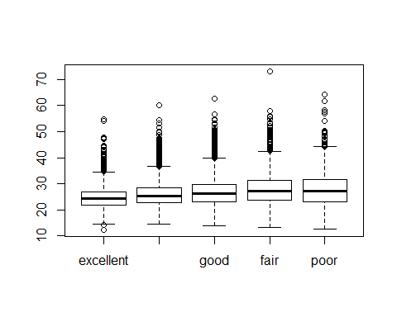

Notice that the first line above is just some arithmetic, but it’s applied to all 20,000 numbers in the cdc data set. That is, for each of the 20,000 participants, we take their weight, divide by their height-squared and then multiply by 703. The result is 20,000 BMI values, one for each respondent. This is one reason why we like R: it lets us perform computations like this using very simple expressions.

1. What does this box plot show? Pick another categorical variable from the data set and see how it relates to BMI. List the variable you chose, why you might think it would have a relationship to BMI, and indicate what the figure seems to suggest.

boxplot(bmi ~ cdc$gender, xlab = "bmi by gender")

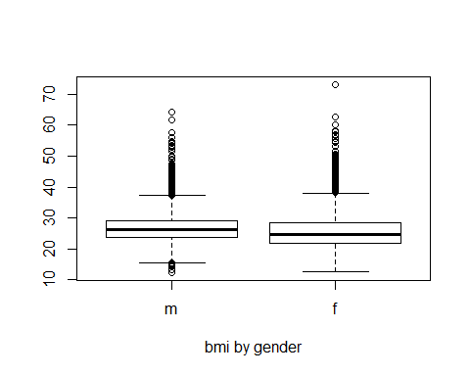

# (5) The “genhlth” boxplot displays a bmi for each genhlth value (from excellent to poor). Though they don’t seem to display huge differences, we can see a trend that people reported having poorer health tended to have higher bmi values and wider the whiskers (meaning bigger data variation). On the other hand, I created above boxplot using gender. I speculated that gender can significantly impact bmi because of different diet and exercise patterns between men and women. The above boxplot does not seem to support the hypothesis. The boxplot seems to be highly similar between m and f, except f has wider whiskers (showing more variation within group - there’s an extreme outliner with a bmi value above 70). Perhaps we can control age and other lifestyle patterns before running the comparison again for gaining better insight of bmi and gender.

Finally, let’s make some histograms. We can look at the histogram for the age of our respondents with the command

hist(cdc$age)

Histograms are generally a very good way to see the shape of a single distribution, but that shape can change depending on how the data is split between the different bins. You can control the number of bins by adding an argument to the command. In the next two lines, we first make a default histogram of bmi and then one with 50 breaks.

hist(bmi)  
hist(bmi, breaks = 50)

Note that you can flip between plots that you’ve created by clicking the forward and backward arrows in the lower right region of RStudio, just above the plots. How do these two histograms compare?

At this point, we’ve done a good first pass at analyzing the information in the BRFSS questionnaire. We’ve found an interesting association between smoking and gender, and we can say something about the relationship between people’s assessment of their general health and their own BMI. We’ve also picked up essential computing tools – summary statistics, subsetting, and plots – that will serve us well throughout this course.

## On Your Own

* Make a scatterplot of weight versus desired weight. Describe the relationship between these two variables.

with(cdc, plot(wtdesire ~ weight))

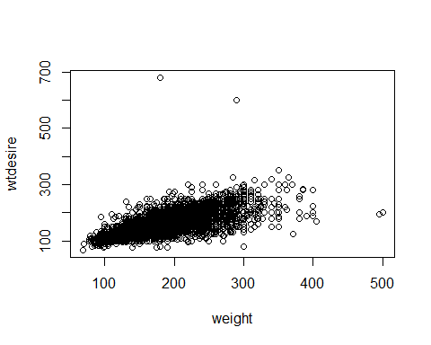 # There’s a linear relationship between the two variables, but people tend to desire about one-third less than their actual weight, e.g. lm(wtdesire ~ weight, data = cdc), coefficient for weight is about 0.639.

* Let’s consider a new variable: the difference between desired weight (wtdesire) and current weight (weight). Create this new variable by subtracting the two columns in the data frame and assigning them to a new object called wdiff.

wdiff <- cdc$wtdesire - cdc$weight

* What type of data is wdiff? If an observation wdiff is 0, what does this mean about the person’s weight and desired weight. What if wdiff is positive or negative? # “wdiff” is a discrete variable. If that is 0, that means there’s no discrepancy between actual and desired weight. If the difference is positive, that means the person wants to be heavier; if negative, the person wants the opposite and he/she desires to lose more weight.
* Describe the distribution of wdiff in terms of its center, shape, and spread, including any plots you use. What does this tell us about how people feel about their current weight?

# statistics  
summary(wdiff)

## Min. 1st Qu. Median Mean 3rd Qu. Max.   
## -300.00 -21.00 -10.00 -14.59 0.00 500.00

IQR(wdiff)

## [1] 21

# plot  
par(mfrow = c(1, 2))  
hist(wdiff, prob = T, main = "distribution of wdiff"); lines(density(wdiff), lwd = 3, col = 4); rug(jitter(wdiff))  
boxplot(wdiff, main = "boxplot of wdiff")

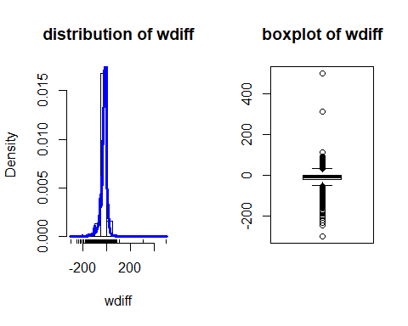 # The histogram (overlayed by a density curve) displays the distribution of wdiff, whereas the boxplot shows the same data with the extra display of outliners. The above summary shows basic statistics of this variable. The distribution slightly skewed to the right (e.g. median < mean, some extreme values on the far right). It has a center (using median) of -10, meaning people tend to desire less weight. The histogram and density curve display a leptokurtic distribution. It’s best to focus on the IQR (so that we can ignore the extreme values on both ends) and see what the majority think about their weight in general. The IQR of 21 (from 75% quartile of 0 to 25% quartile of -21) indicates that people tend to desire less weight, i.e. 75% of samples in this study have wdiff 0 or less as a good indicator of majority desires to weight less, the IQR of 21 implies how much less they are desiring in general.

* Using numerical summaries and a side-by-side box plot, determine if men tend to view their weight differently than women.

cdc$wdiff <- wdiff  
aggregate(wdiff ~ gender, data = cdc, summary)

## gender wdiff.Min. wdiff.1st Qu. wdiff.Median wdiff.Mean wdiff.3rd Qu.  
## 1 m -300.00000 -20.00000 -5.00000 -10.70613 0.00000  
## 2 f -300.00000 -27.00000 -10.00000 -18.15118 0.00000  
## wdiff.Max.  
## 1 500.00000  
## 2 83.00000

with(cdc, boxplot(wdiff ~ gender, main = "wdiff by gender"))

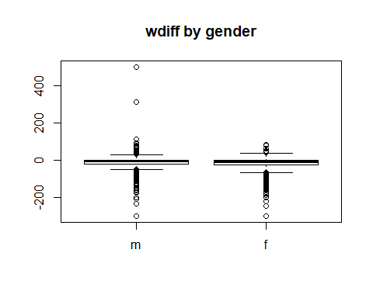 # there’s no distinguishable difference between men and women on desired weight. Men have few more extreme values on the upper end, driving their mean higher than women (-10.7 vs -18.2). The median of men (-5) is slightly higher than women (-10) signals that although both men and women desire to weight less than actual, it’s likely that women have stronger desire to have more weight loss than men.

* Now it’s time to get creative. Find the mean and standard deviation of weight and determine what proportion of the weights are within one standard deviation of the mean.

x <- mean(cdc$weight); x

## [1] 169.683

s <- sd(cdc$weight); s

## [1] 40.08097

library(dplyr)

## Warning: package 'dplyr' was built under R version 3.5.1

##   
## Attaching package: 'dplyr'

## The following objects are masked from 'package:stats':  
##   
## filter, lag

## The following objects are masked from 'package:base':  
##   
## intersect, setdiff, setequal, union

cdc %>%   
 mutate(flag = ifelse(weight > x - s & weight < x + s, 1, 0)) %>%  
 select(flag) %>%  
 ftable(.) %>%  
 prop.table

## Warning: package 'bindrcpp' was built under R version 3.5.1

## x 0 1  
##   
## 0.2924 0.7076

# mean is equal to 169.683, whereas sd is equal to 40.08097. About 71% is within one standard deviation of the mean.

This is a product of OpenIntro that is released under a [Creative Commons Attribution-ShareAlike 3.0 Unported](http://creativecommons.org/licenses/by-sa/3.0). This lab was adapted for OpenIntro by Andrew Bray and Mine Çetinkaya-Rundel from a lab written by Mark Hansen of UCLA Statistics.